Logical Cohesion

📌 Definition:
# Source: AI Source: Provided by: [Data Path: Persons Table -> ID Column: 1, Name_En Column: Motasem Essam] -> From: [Chatgpt (GPT‑5 Mini)] on [12/9/2025]
Logical Cohesion occurs when elements of a class/module are grouped because they are logically categorized together, even if they perform different, unrelated tasks.

🧠 Simple idea:
# Source: AI Source: Provided by: [Data Path: Persons Table -> ID Column: 1, Name_En Column: Motasem Essam] -> From: [Chatgpt (GPT‑5 Mini)] on [12/9/2025]
“Grouped by category, not by function or data” 🧩

🔍 Key characteristics:
# Source: AI Source: Provided by: [Data Path: Persons Table -> ID Column: 1, Name_En Column: Motasem Essam] -> From: [Chatgpt (GPT‑5 Mini)] on [12/9/2025]
- Methods are related conceptually, but not functionally
- 🟠 Weaker cohesion than procedural or communicational
- ❌ Can lead to hard-to-maintain classes
- ⚙️ Common in utility or “helper” classes

📊 Example:
# Source: AI Source: Provided by: [Data Path: Persons Table -> ID Column: 1, Name_En Column: Motasem Essam] -> From: [Chatgpt (GPT‑5 Mini)] on [12/9/2025]
class Utility {

void printReport(String report) {
System.out.println(report);
}

boolean validateEmail(String email) {
return email.matches("^[A-Za-z0-9+_.-]+@(.+)$");
}

int calculateSalary(int hours, int rate) {
return hours * rate;
}
}
- ❌ Utility class has report printing, email validation, and salary calculation
- 🟠 Methods are logically related as utilities, but not cohesive by function or data

🛡️ Avoiding Logical Cohesion Example:
# Source: AI Source: Provided by: [Data Path: Persons Table -> ID Column: 1, Name_En Column: Motasem Essam] -> From: [Chatgpt (GPT‑5 Mini)] on [12/9/2025]
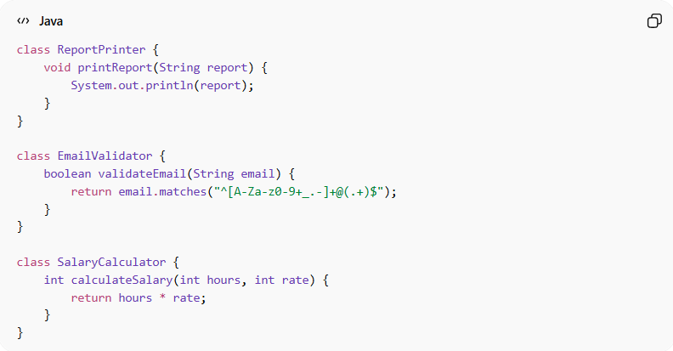
class ReportPrinter {
void printReport(String report) {
System.out.println(report);
}
}

class EmailValidator {
boolean validateEmail(String email) {
return email.matches("^[A-Za-z0-9+_.-]+@(.+)$");
}
}

class SalaryCalculator {
int calculateSalary(int hours, int rate) {
return hours * rate;
}
}
Usage:
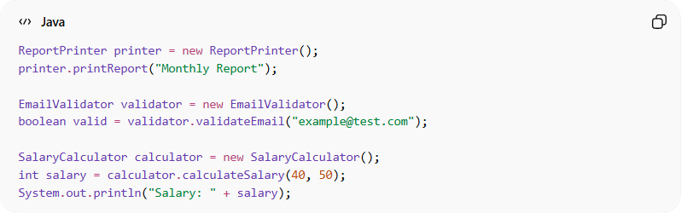
ReportPrinter printer = new ReportPrinter();
printer.printReport("Monthly Report");

EmailValidator validator = new EmailValidator();
boolean valid = validator.validateEmail("example@test.com");

SalaryCalculator calculator = new SalaryCalculator();
int salary = calculator.calculateSalary(40, 50);
System.out.println("Salary: " + salary);
✅ Key improvements:
- 🧩 Each class has a single responsibility
- 🔄 Methods are focused and cohesive
- ⚙️ Easier to maintain, test, and reuse
- 🔗 Avoids “catch-all” utility class with unrelated functions

⚙️ Best Practice:
# Source: AI Source: Provided by: [Data Path: Persons Table -> ID Column: 1, Name_En Column: Motasem Essam] -> From: [Chatgpt (GPT‑5 Mini)] on [12/9/2025]
- Split logically grouped methods into specialized, focused classes
- Follow Single Responsibility Principle (SRP)
- Avoid creating “catch-all” utility classes
- Aim for functional or communicational cohesion

